A PROJECT REPORT ON
IMPLEMENTATION OF GITOPS-BASED CI/CD PIPELINE
USING AZURE, TERRAFORM, AKS & ARGOCD
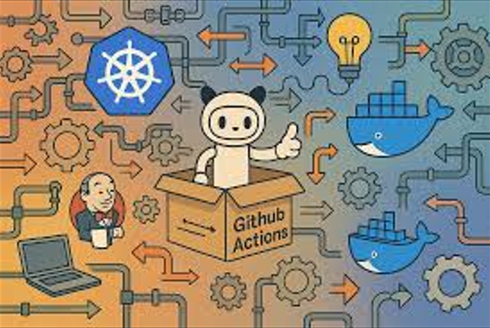
Group:

Mainak Das
Gourov Roy Choudhury
Amrita Sannigrahi

End-to-End Cloud-Native Deployment of Recruitment Microservices on Azure AKS
This is a complete GitOps-based CI/CD system on Azure using Terraform for infrastructure, AKS for orchestration, Helm for templating, Azure DevOps for CI, and ArgoCD for CD. The application is a Node.js HR system backed by MongoDB using persistent storage, health probes, and secure secrets. Every code commit automatically builds, pushes, and deploys to Kubernetes without manual intervention.
This project implements a complete DevOps + Cloud-Native pipeline using:
- Terraform → Infrastructure provisioning on Azure
- AKS (Azure Kubernetes Service) → Container orchestration
- ACR (Azure Container Registry) → Image storage
- CI/CD (Azure DevOps + GitHub) → Build & push images
- Helm → Kubernetes application templating
- ArgoCD (GitOps) → Automated Kubernetes deployment
- Node.js + MongoDB → Application stack

TREE STRUCTURE
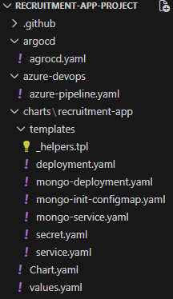
Dockerfile to build the custom image.
FROM node:18-alpine

WORKDIR /app

COPY package*.json ./
RUN npm install --production

COPY . .

EXPOSE 3000

CMD ["node", "server.js"]

Configuration details -

1. Infrastructure Provisioning with Terraform (IAC) – with code
2. CI Pipeline (Azure DevOps) – with code
3. Helm Chart (Application Packaging) – with code
4. Continuous Deployment with ArgoCD – with code
5. Cluster Details – Azure and Kubernetes
6. Monitoring - Prometheus and Grafana

STEP 1: Infrastructure Provisioning (Terraform)
**Create AKS cluster, ACR, node pools, and storage automatically using Terraform.
Provider Configuration (provider.tf)

terraform {
required_providers {
azurerm = {
source = "hashicorp/azurerm"
version = ">= 4.0.0"
}
kubernetes = {
source = "hashicorp/kubernetes"
version = ">= 2.0.0"
}
}
}

provider "azurerm" {
features {}
subscription_id = "d008c7cc-9795-4292-bf79-74ae52cda63d"
}

Using Existing Resource Group (resource-group.tf)

data "azurerm_resource_group" "main" {
name = "LabsKraft360"
}

AKS Cluster Creation (aks.tf)

resource "azurerm_kubernetes_cluster" "aks" {
name = "mainak-aks"
location = data.azurerm_resource_group.rg.location
resource_group_name = data.azurerm_resource_group.rg.name
dns_prefix = "mainak"

node_resource_group = "mainak-aks-nodes"

default_node_pool {
name = "systempool"
node_count = 4
vm_size = "Standard_D2ads_v6"
type = "VirtualMachineScaleSets"
}

identity {
type = "SystemAssigned"
}

network_profile {
network_plugin = "azure"
load_balancer_sku = "standard"
}

Azure Container Registry (acr.tf)

resource "azurerm_container_registry" "acr" {
name = "acrmainak"
resource_group_name = data.azurerm_resource_group.rg.name
location = data.azurerm_resource_group.rg.location
sku = "Standard"
admin_enabled = false
}

AKS → ACR Access (role-acr-aks.tf)

resource "azurerm_role_assignment" "aks_acr_pull" {
principal_id = azurerm_kubernetes_cluster.aks.kubelet_identity[0].object_id
role_definition_name = "AcrPull"
scope = azurerm_container_registry.acr.id

}
Persistent Storage (storage.tf)

resource "kubernetes_storage_class_v1" "azure_disk" {
metadata {
name = "managed-premium-retain"
}

storage_provisioner = "disk.csi.azure.com"
reclaim_policy = "Retain"
volume_binding_mode = "WaitForFirstConsumer"

parameters = {
skuName = "Premium_LRS"
}
}

STEP 2: CI Pipeline (Azure DevOps)
Manifest – azure-pipeline.yaml
trigger:
- azure-devops

variables:
imageName: recruitment-app
acrLoginServer: acrmainak.azurecr.io
tag: $(Build.BuildId)

pool:
vmImage: ubuntu-latest

steps:
- checkout: self
persistCredentials: true

# Build and Push Docker Image
- task: Docker@2
displayName: Build and Push Docker Image
inputs:
command: buildAndPush
repository: $(imageName)
dockerfile: Dockerfile
containerRegistry: recruitment-DR-connection
tags: |
$(tag)

# Update Helm values.yaml (only recruitmentApp.image.tag)
- script: |
echo "Updating Helm values.yaml (app image only)"
sed -i '/recruitmentApp:/,/mongodb:/ s/^\(\s*tag:\).*/\1 "'"$(tag)"'"/' charts/recruitment-app/values.yaml

git config user.email "azure-devops@pipeline.com"
git config user.name "azure-devops"

git fetch origin
git checkout -B azure-devops origin/azure-devops

git add charts/recruitment-app/values.yaml
git commit -m "Update recruitment-app image tag to $(tag)"
git push https://$GITHUB_PAT@github.com/Mainakdas73/Recruitment-App-Project.git azure-devops
displayName: Update Helm Image Tag
env:
GITHUB_PAT: $(GITHUB_PAT)

STEP 3: Helm Chart (Application Packaging)
values.yaml
namespace: recruitment-ns
recruitmentApp:
name: recruitment-app
replicas: 2

image:
repository: acrmainak.azurecr.io/recruitment-app
tag: "10643" This tag is updated by CI-pipeline after pushing the image to registry
containerPort: 3000

service:
name: recruitment-service
type: LoadBalancer
port: 80
targetPort: 3000

env:
MONGO_URL: mongodb://mongo:27017/hr_system
NODE_ENV: production

mongodb:
name: mongo
replicas: 1

image:
repository: mongo
tag: "6.0.13"
pullPolicy: IfNotPresent

containerPort: 27017

service:
name: mongo
type: ClusterIP
port: 27017

pvc:
name: mongo-pvc
accessMode: ReadWriteOnce
storageClassName: managed-premium-retain
size: 5Gi

secret:
name: mongo-secret
username: hrapp
password: hrapp123

Deployment Template (deployment.yaml)

apiVersion: apps/v1
kind: Deployment
metadata:
name: {{ .Values.recruitmentApp.name }}
labels:
{{- include "recruitment.labels" . | nindent 4 }}
spec:
replicas: {{ .Values.recruitmentApp.replicas }}
selector:
matchLabels:
app: {{ .Values.recruitmentApp.name }}
template:
metadata:
labels:
app: {{ .Values.recruitmentApp.name }}
spec:
containers:
- name: recruitment-app
image: "{{ .Values.recruitmentApp.image.repository }}:{{ .Values.recruitmentApp.image.tag }}"
imagePullPolicy: IfNotPresent

ports:
- containerPort: {{ .Values.recruitmentApp.containerPort }}

env:
- name: MONGO_URL
value: {{ .Values.recruitmentApp.env.MONGO_URL | quote }}
- name: NODE_ENV
value: {{ .Values.recruitmentApp.env.NODE_ENV | quote }}
- name: PORT
value: {{ .Values.recruitmentApp.containerPort | quote }}

resources:
requests:
cpu: "100m"
memory: "256Mi"
limits:
cpu: "500m"
memory: "512Mi"

# Pod is READY only when MongoDB is connected
readinessProbe:
httpGet:
path: /health
port: {{ .Values.recruitmentApp.containerPort }}
initialDelaySeconds: 45
periodSeconds: 10
failureThreshold: 6

# Pod is ALIVE as long as the app process is running
livenessProbe:
httpGet:
path: /healthz
port: {{ .Values.recruitmentApp.containerPort }}
initialDelaySeconds: 60
periodSeconds: 20
failureThreshold: 5

MongoDB StatefulSet Manifest – mongo-deployment.yaml

apiVersion: apps/v1
kind: StatefulSet
metadata:
name: {{ .Values.mongodb.name }}
namespace: {{ .Values.namespace }}
spec:
serviceName: {{ .Values.mongodb.service.name }}
replicas: {{ .Values.mongodb.replicas }}
selector:
matchLabels:
app: {{ .Values.mongodb.name }}
template:
metadata:
labels:
app: {{ .Values.mongodb.name }}
spec:
containers:
- name: mongo
image: "{{ .Values.mongodb.image.repository }}:{{ .Values.mongodb.image.tag }}"
imagePullPolicy: IfNotPresent
ports:
- containerPort: {{ .Values.mongodb.containerPort }}
volumeMounts:
- name: mongo-storage
mountPath: /data/db
- name: mongo-init
mountPath: /docker-entrypoint-initdb.d
volumes:
- name: mongo-init
configMap:
name: mongo-init

volumeClaimTemplates:
- metadata:
name: mongo-storage
spec:
accessModes:
- {{ .Values.mongodb.pvc.accessMode }}
storageClassName: {{ .Values.mongodb.pvc.storageClassName }}
resources:
requests:
storage: {{ .Values.mongodb.pvc.size }}

Application service Manifest – service.yaml

apiVersion: v1
kind: Service
metadata:
name: {{ .Values.recruitmentApp.service.name }}
spec:
type: {{ .Values.recruitmentApp.service.type }}
selector:
app: {{ .Values.recruitmentApp.name }}
ports:
- port: {{ .Values.recruitmentApp.service.port }}
targetPort: {{ .Values.recruitmentApp.service.targetPort }}

Mongo service Manifest – mongo-service.yaml

apiVersion: v1
kind: Service
metadata:
name: {{ .Values.mongodb.service.name }}
namespace: {{ .Values.namespace }}
spec:
clusterIP: None
selector:
app: {{ .Values.mongodb.name }}
ports:
- port: {{ .Values.mongodb.service.port }}
targetPort: {{ .Values.mongodb.containerPort }}

Mongo secret Manifest – secret.yaml

apiVersion: v1
kind: Secret
metadata:
name: {{ .Values.secret.name }}
type: Opaque
data:
username: {{ .Values.secret.username | b64enc }}
password: {{ .Values.secret.password | b64enc }}

Mongo configmap Manifest – mongo-init-configmap.yaml

apiVersion: v1
kind: ConfigMap
metadata:
name: mongo-init
data:
init.js: |
db = db.getSiblingDB("hr_system");
db.createUser({
user: "hrapp",
pwd: "hrapp123",
roles: [{ role: "readWrite", db: "hr_system" }]
});

STEP 4: Continuous Deployment with ArgoCD
**Automatic Kubernetes deployment from GitHub repository.
ArgoCD Application manifest - argocd.yaml
apiVersion: argoproj.io/v1alpha1
kind: Application
metadata:
name: recruitment-app
namespace: argocd
spec:
project: default

source:
repoURL: https://github.com/Mainakdas73/Recruitment-App-Project.git
targetRevision: azure-devops
path: charts/recruitment-app
helm:
valueFiles:
- values.yaml

destination:
server: https://kubernetes.default.svc
namespace: recruitment-ns

syncPolicy:
automated:
prune: true
selfHeal: true
syncOptions:
- CreateNamespace=true

STEP 5: Final Deployment Result

kubectl get svc -n recruitment-ns
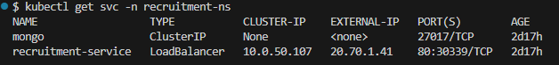
recruitment-service LoadBalancer 20.70.1.41
Cluster details
$ kubectl get app -n argocd
NAME SYNC STATUS HEALTH STATUS
recruitment-app Synced Healthy

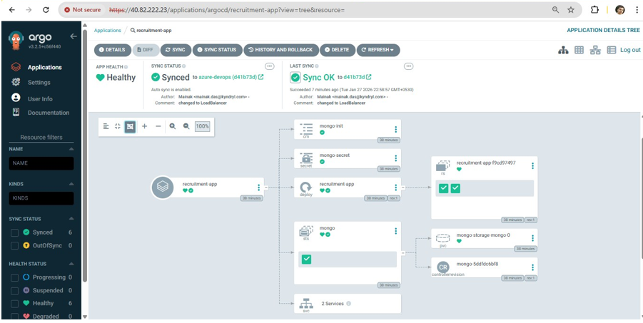

$ kubectl get all -n recruitment-ns

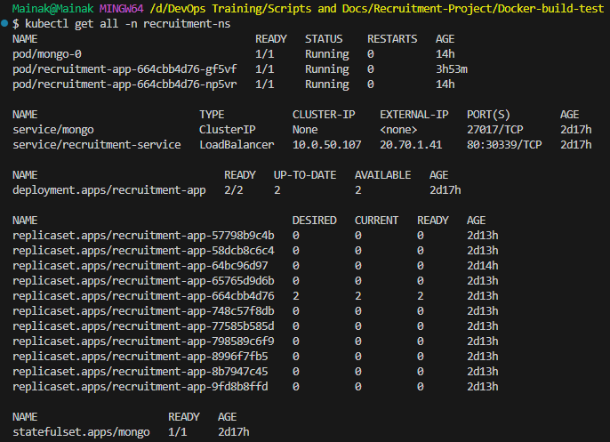

AZURE CONFIGURATIONS [pipeline and service connections used]

Pipeline in Azure:

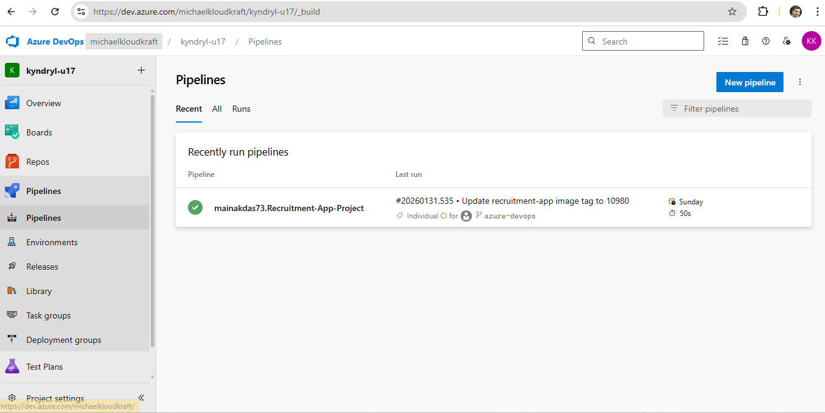

Two Service Connections in Azure that has been used in this project for authentication:

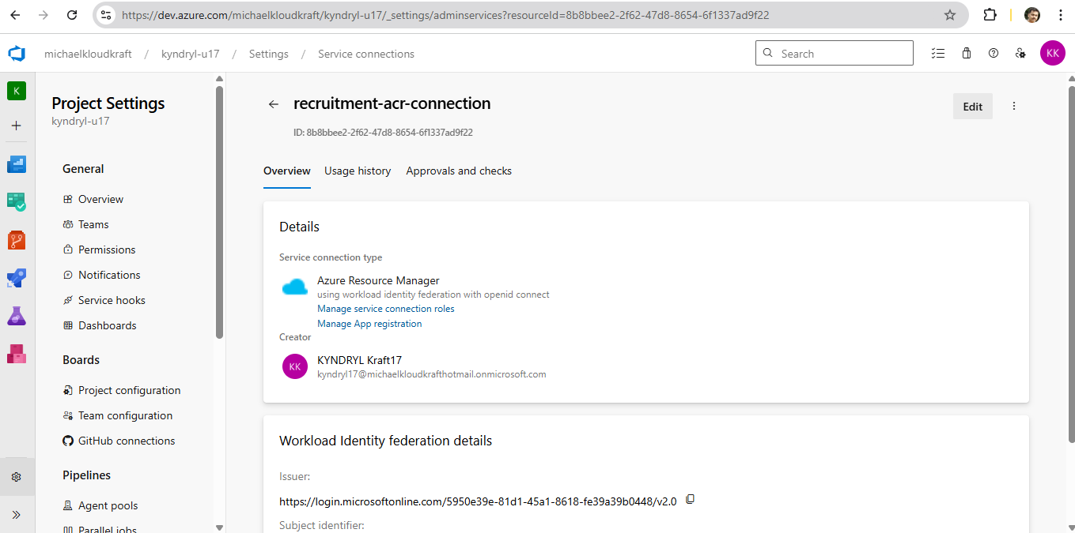

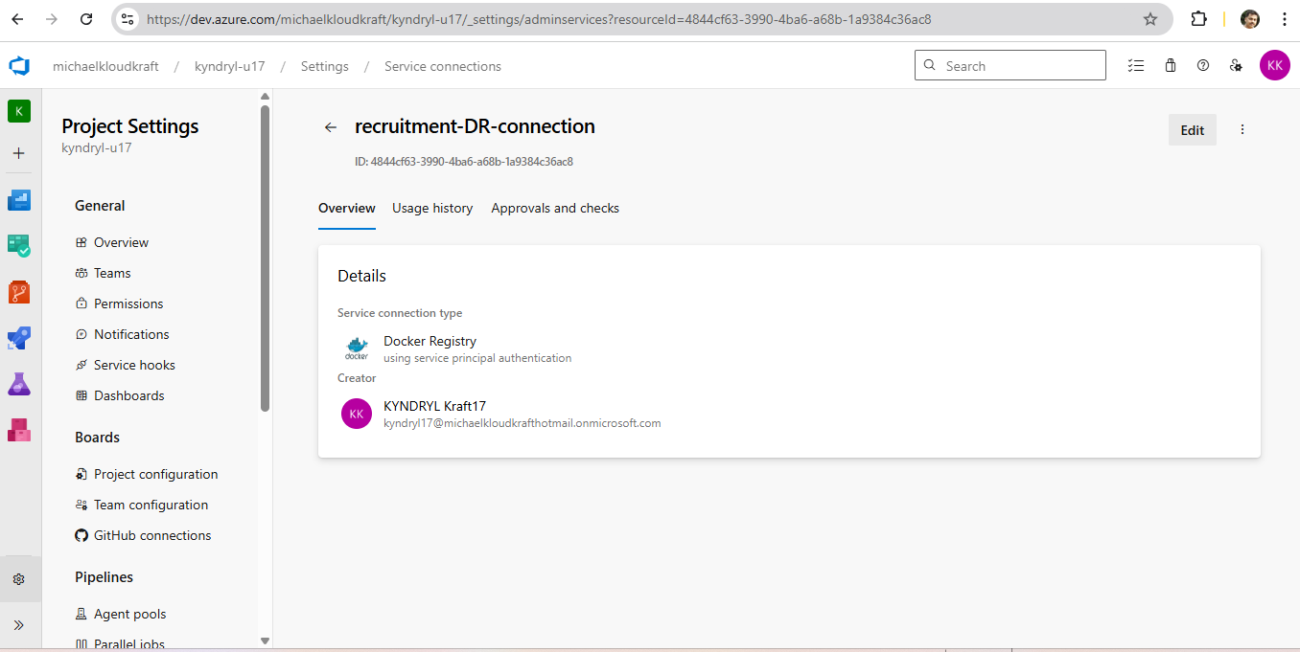

GitHub repository for Recruitment-app

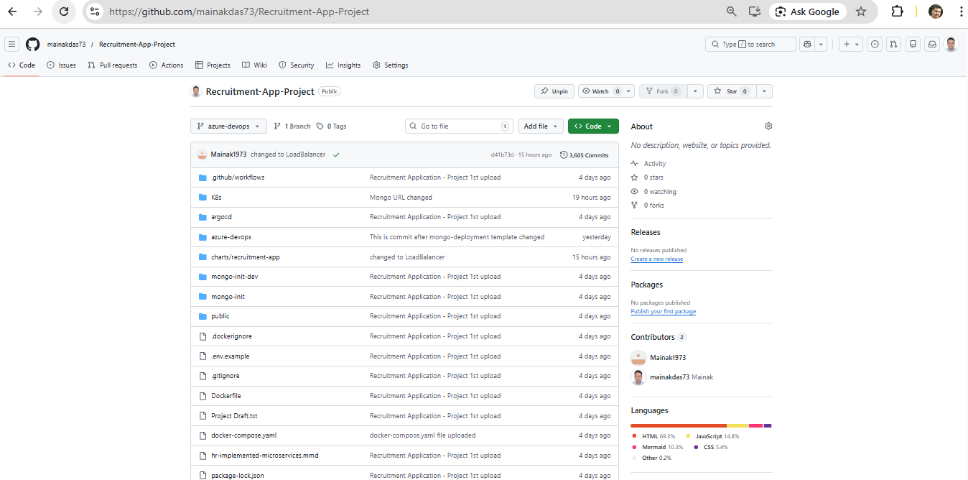

Azure Container Registry (ACR)

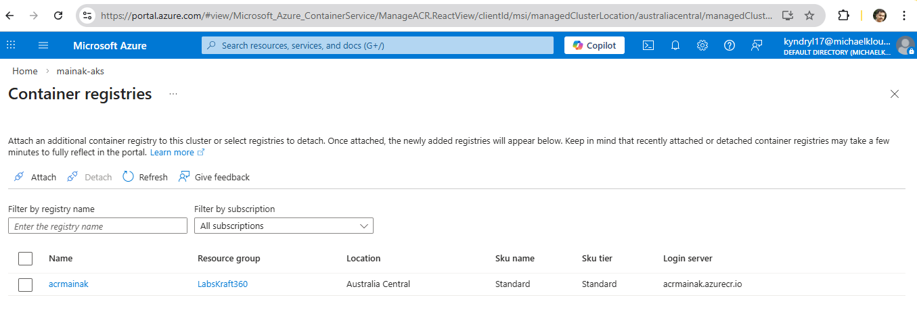

MONITORING – Argocd, Prometheus and Grafana

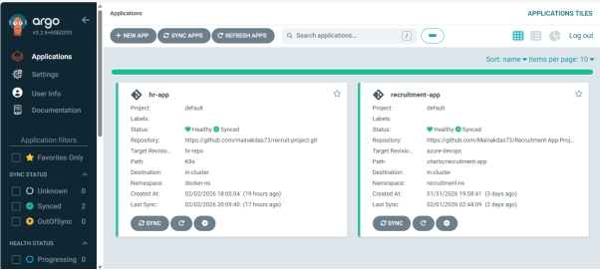

Configuring Grafana (getting Prometheus IP to create a connection in Grafana)

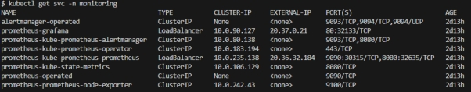
Grafana Monitoring Dashboard for Namespace recruitment-ns

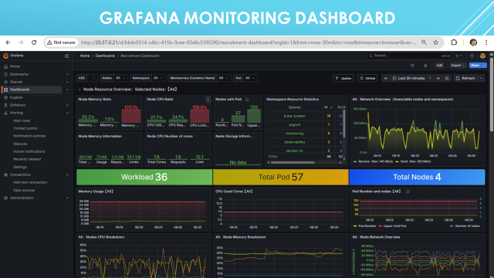

Kibana Log Monitoring

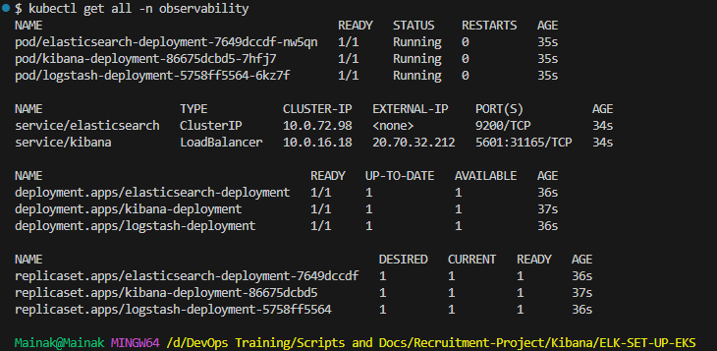

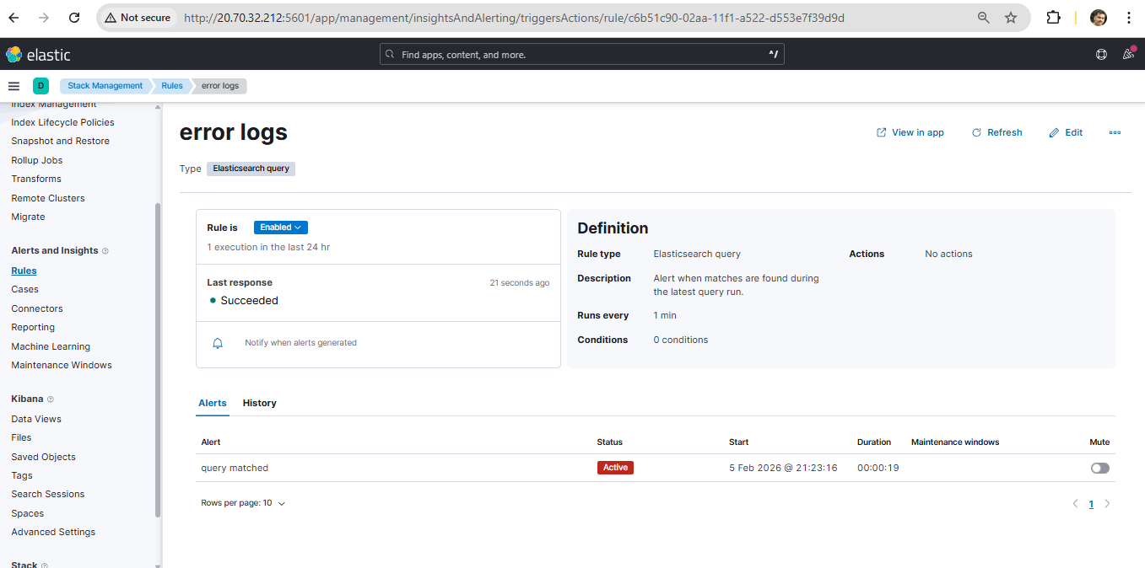

Front end User Interface (After Implementation)

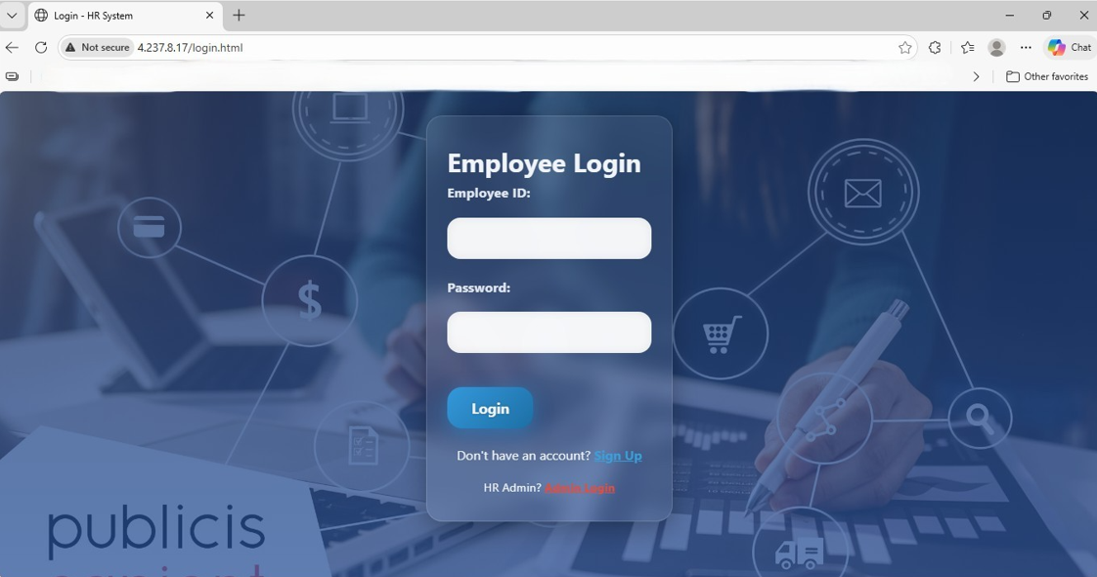

URL details:
Argocd - http://20.37.1.13
user name – admin
password - OeOOG5akdhyaJFqO
Grafana - http://20.37.0.21
user name - admin,
password - K8XpsnvHcP7U6uScE7IRGi6cuGb73EVhfFsz1BmT
Kibana – http://20.70.32.212:5601

Configurations:

https://github.com/mainakdas73/Recruitment-App-Project
Cluster Name – mainak-aks
Cluster Registry Name – acrmainak
Azure Resource Manager - recruitment-acr-connection
Docker Registry Service connection - recruitment-DR-connection

